**EC2 CPU Monitoring and Auto-Alert System using AWS CloudWatch**

**Step 1: Create an EC2 Instance**

* Launch a new EC2 instance from the AWS Console.

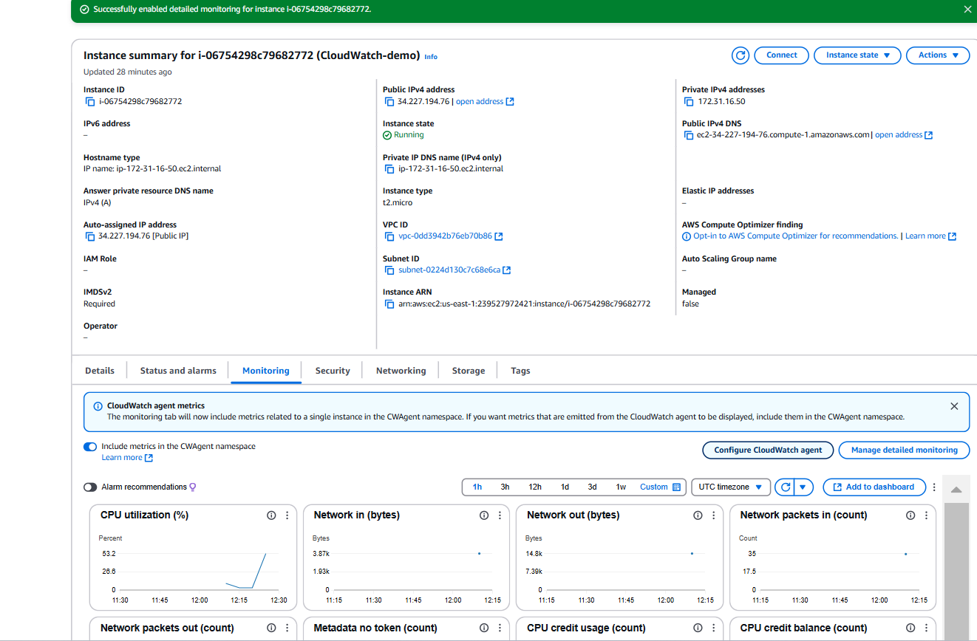

**Step 2: Enable Detailed Monitoring**

* Go to the **Monitoring** tab of your EC2 instance.
* Click on **Manage detailed monitoring** and enable it.

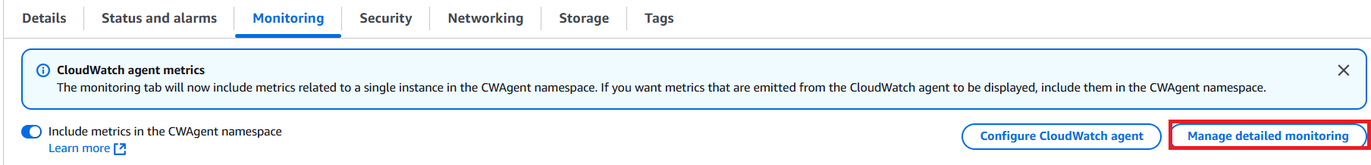

**Step 3: Simulate a CPU Spike**

* SSH into your EC2 instance.
* Run the following command to create a Python script:

nano cpu_spike.py

Paste the below script into the file:

import time

def simulate_cpu_spike(duration=30, cpu_percent=80):

print(f"Simulating CPU spike at {cpu_percent}%...")

start_time = time.time()

# Calculate the number of iterations needed to achieve the desired CPU utilization

target_percent = cpu_percent / 100

total_iterations = int(target_percent * 5_000_000) # Adjust the number as needed

# Perform simple arithmetic operations to spike CPU utilization

for _ in range(total_iterations):

result = 0

for i in range(1, 1001):

result += i

# Wait for the rest of the time interval

elapsed_time = time.time() - start_time

remaining_time = max(0, duration - elapsed_time)

time.sleep(remaining_time)

print("CPU spike simulation completed.")

if __name__ == '__main__':

# Simulate a CPU spike for 30 seconds with 80% CPU utilization

simulate_cpu_spike(duration=30, cpu_percent=80)

**Step 4: Go to CloudWatch Metrics**

* Open **CloudWatch** in the AWS Console.
* Click on **Metrics** in the left-hand menu

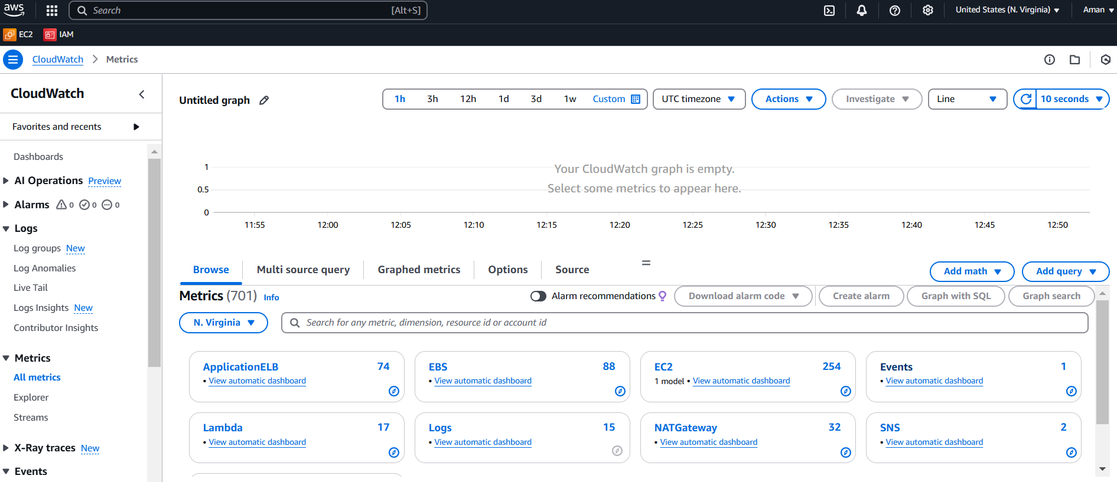

**Step 5: Select EC2 Metrics**

* Select **EC2** under available metric namespaces.

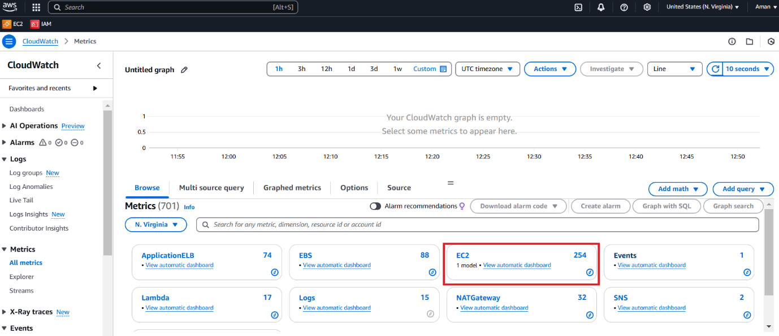

**Step 6: Choose Per-Instance Metrics**

* Click on **Per-Instance Metrics**.
* Select your EC2 instance ID.

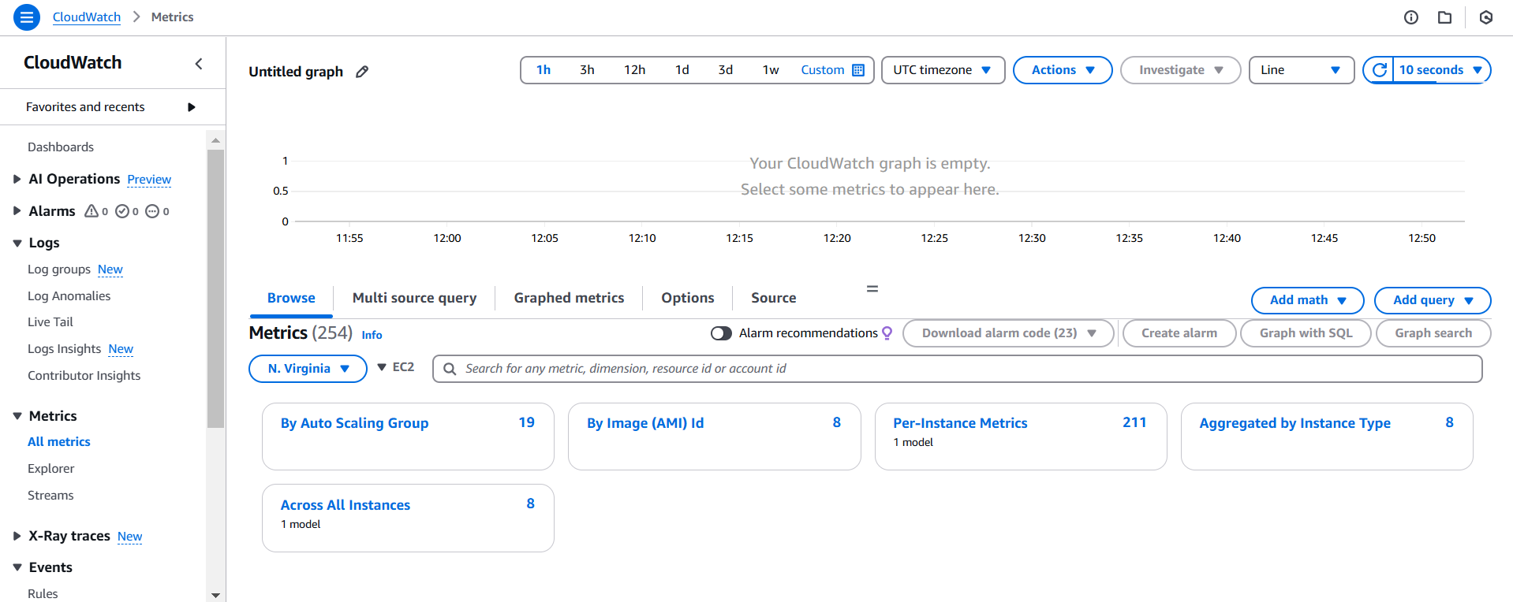

**Step 7: Create an Alarm**

* In the left-hand menu, select **Alarms**.
* Click on **Create alarm**.

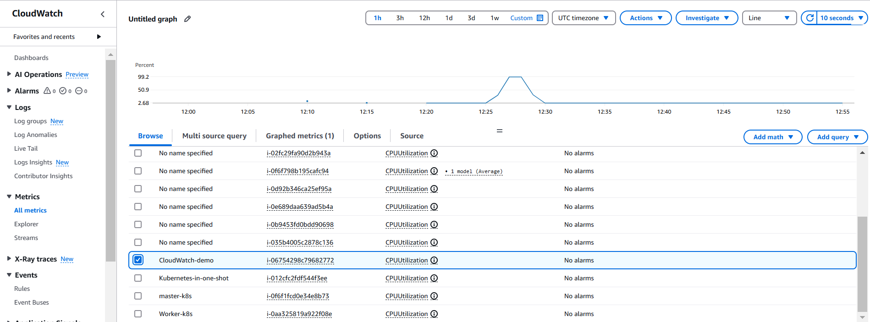

**Step 8: Configure Alarm Conditions**

* Select the metric (e.g., CPUUtilization).
* Set the condition (e.g., whenever CPU utilization is **greater than 50%**).

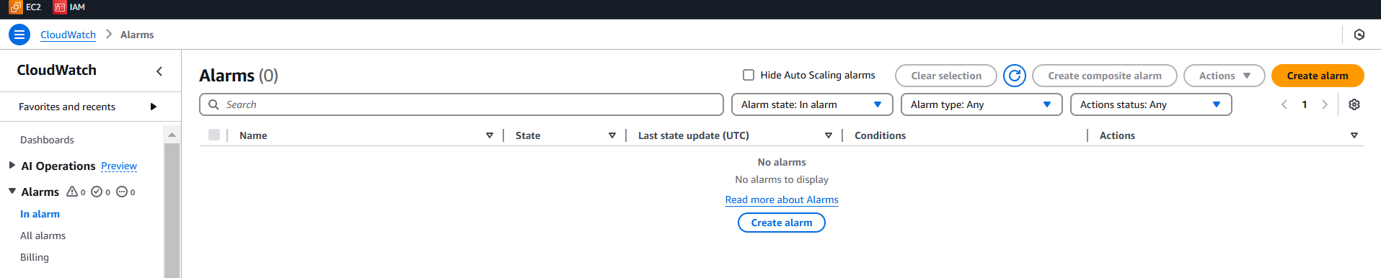

**Step 9: Notification Setup**

* Provide your **email address** for alarm notifications.
* (You will receive a confirmation email to subscribe to the SNS topic.)

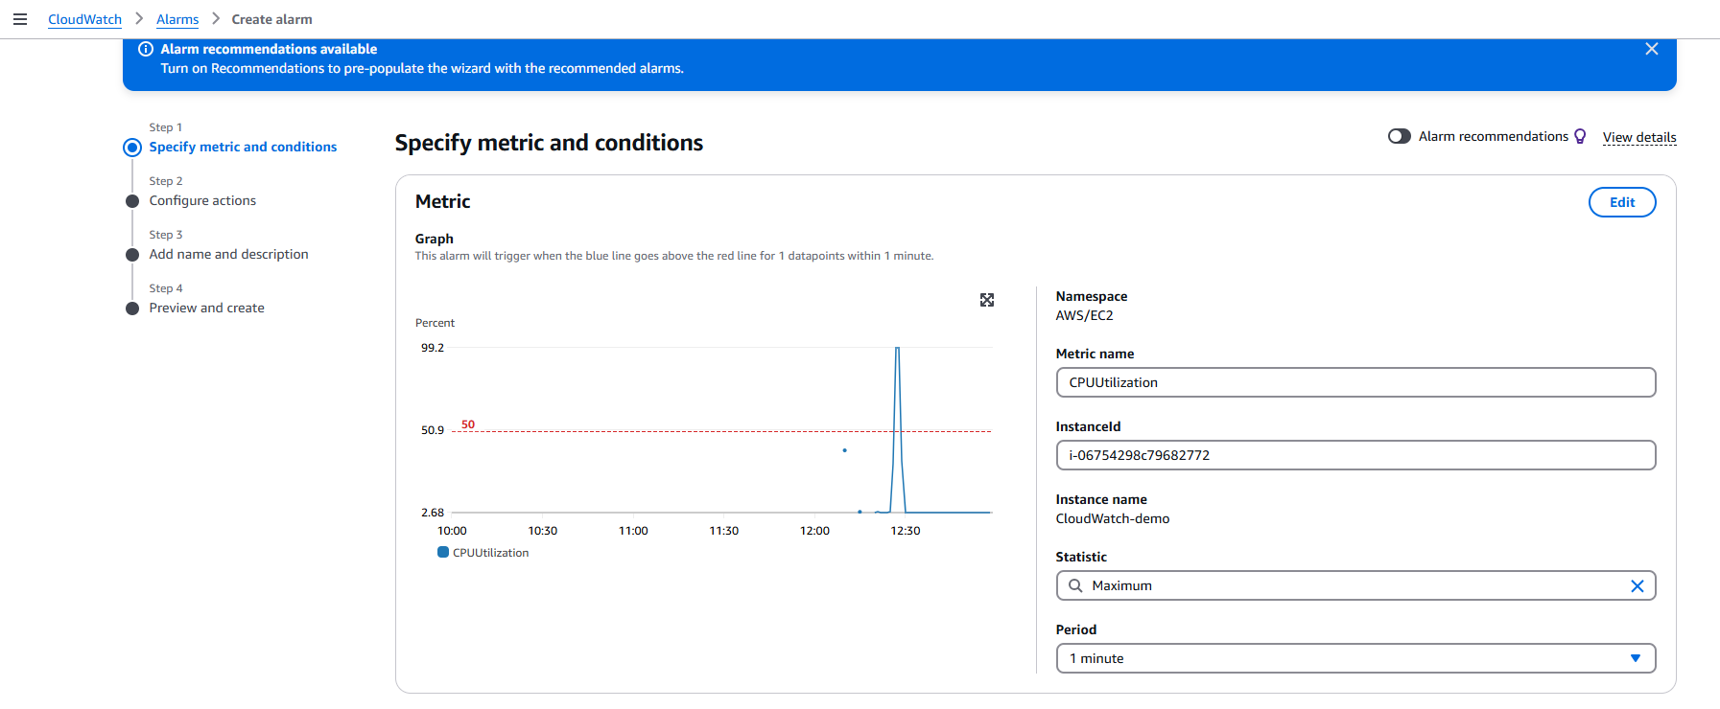

**Step 10: Name and Describe the Alarm**

* Enter a descriptive name and optional description for the alarm.

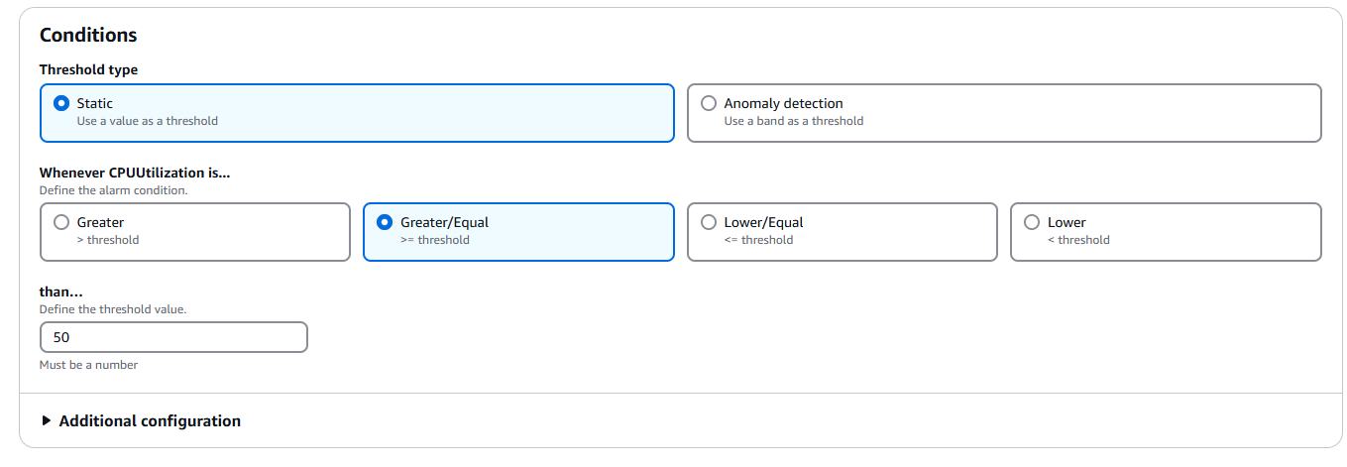

**Step 11: Email Confirmation**

* Check your email and confirm the subscription.

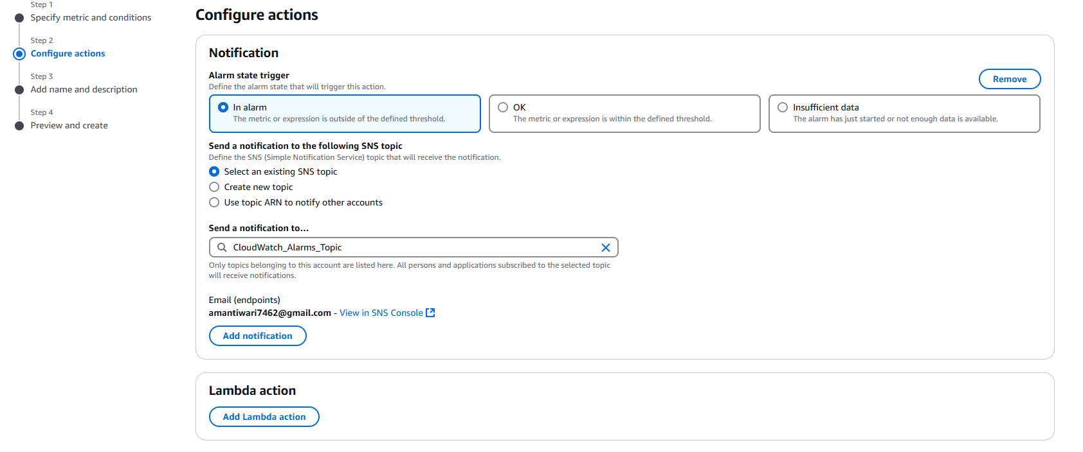

**Step 11->**Provide the name and description of the alert

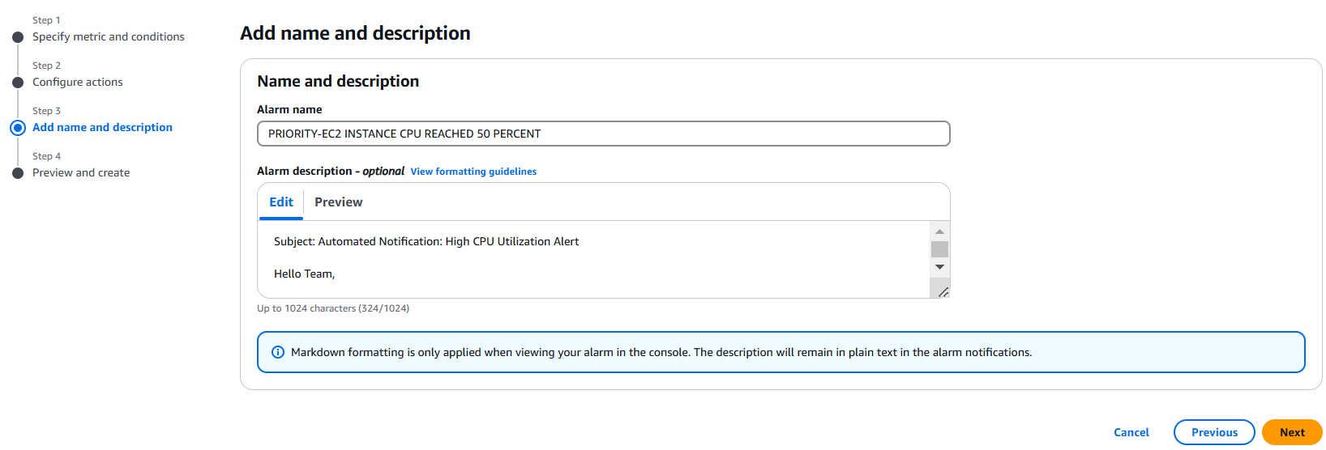

Step 12->You will get the email option to confirm

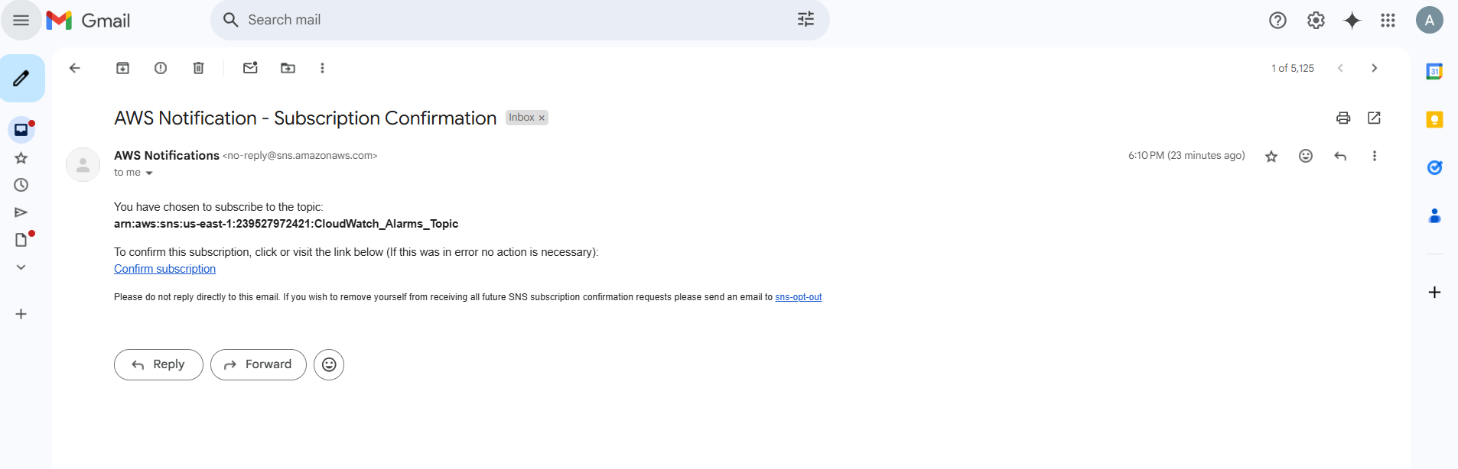

Step 13-> you get similar picture

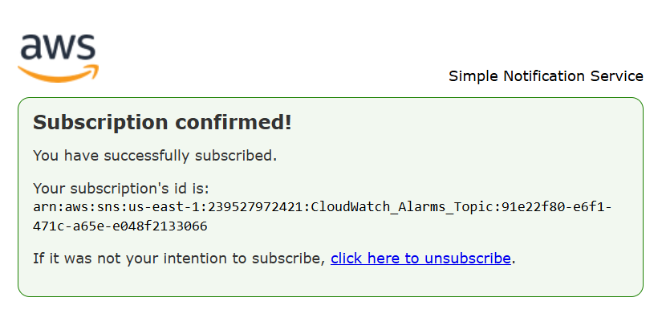

Step 14->

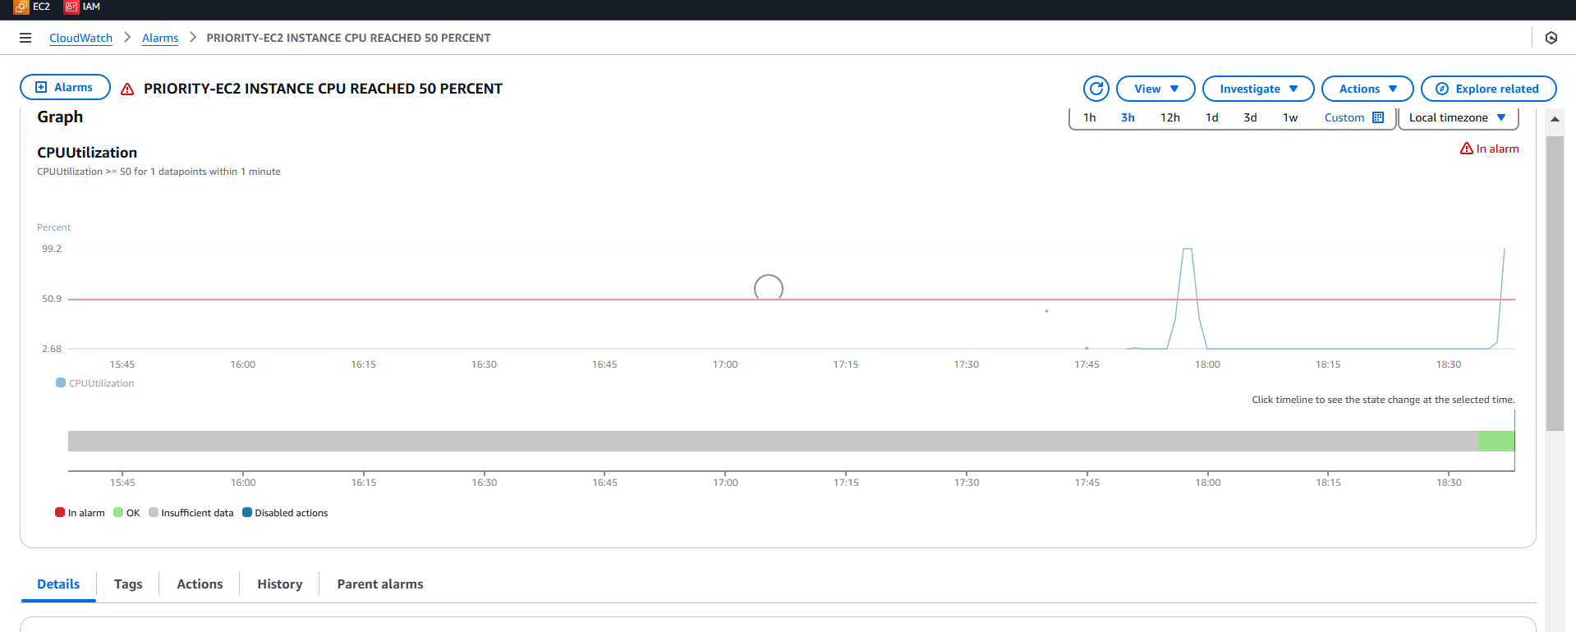

Step 15-> Email Which you will get after

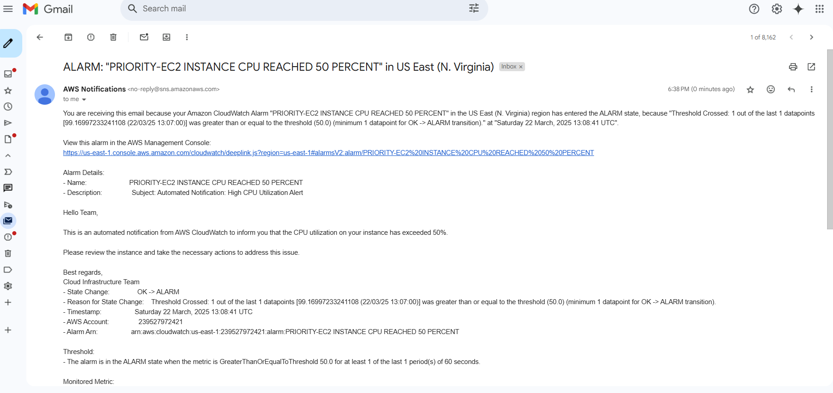

Step 16-> Once spike is generated you will get the output similar to this 